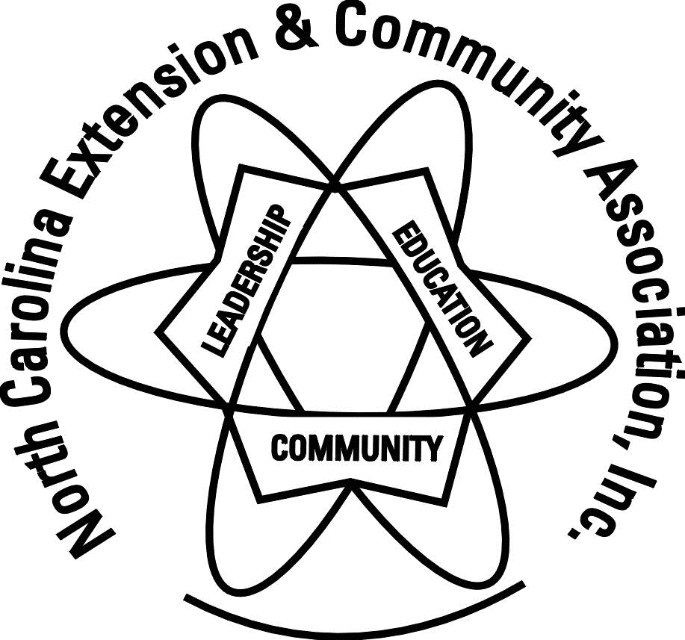
North Carolina Extension & Community Association, Inc.
2019 Conference Registration
October 20-23, 2019
Lambuth Inn, Lake Junaluska

Mountains of Opportunity

Name __________________________________________________________________________ County _____________________________
Address ________________________________________________City __________________________ State _____ Zip code ____________
E-mail ______________________________________________________________________ Phone ______________________________________

Special dietary needs- include all foods due to allergies or religious beliefs:
______________________________________________________________________________________________________________________________
In case of an emergency, contact: _____________________________________________________________________________________
Emergency Daytime Phone ________________________________ Emergency Evening Phone___________________________

I am a: (check all that apply)
_____ Leadership Team _____ County President _____ Past State President _____ Liaison Agent
_____ NCCE Administrator _____ Guest _____ First Time _____EMFV

_______ Tour – Tuesday, October 22. ______ Participate in ECA Chorus
Hands on Workshops - $8.00 each
_______ Memory Necklace
_______ Creative Greeting Cards
_______ Quilted Star Ornament
_______ Christmas Ornament
I would also like to purchase Guest Meals
_____Sunday Dinner -$30.00
_____Monday Breakfast - $15.00
_____Monday Lunch - $25.00
_____Monday Dinner - $30.00
_____Tuesday Breakfast - $15.00
_____Tuesday Lunch - $25.00
____Tuesday Dinner - $30.00
_____Wednesday Breakfast - $15.00

Registration Deadline:

Full Registration (by 9-27) $140.00 _______
Late Registration (after 9-27) $160.00 _______
Hands on Workshops $ _____
Guest Meals $ _____

TOTAL
Registration & Fees $ ________

(Registration fees transferable, not refundable)

Make checks payable to:
West District ECA & mail to:
Mary Sue Boyles
387 South Highway 18
Lawndale, NC 28090

NCECA Service Longevity Awards

Due September 15

Recognition will be given to those achieving longevity in membership. Those who have achieved 25 years and 5-year increments there after, as a member will be recognized. County Council Presidents should submit names of members who deserve this recognition. Please send only one report per county!

Please print or type the name, as it should appear on the certificate

Name | Year Joined | County | District

Remembrance Ceremony: A Remembrance Ceremony honoring ECA members who have passed away since the last Conference will be held during the Banquet on Tuesday night. Submissions should be made with registration. Additional submission can be made through October 1st. Please have your information in on time to maintain the dignity of the ceremony. List names and counties of deceased.
Name ______________________________________________________ County__________________
Name ______________________________________________________ County__________________
Name ______________________________________________________ County__________________

OUTSTANDING SERVICE AWARD
If your county has NOT named and submitted an Outstanding Volunteer name to Geri, it’s not too late!

NAME _______________________________________________________________ COUNTY __________________________________

NCECA State Conference
October 20-23, 2019
Lambuth Inn, Lake Junaluska

Mountains of Opportunity

2019 NCECA Conference Agenda
The schedule for this year’s conference is a little different . . . take notice!!

Sunday, October 20
4:00-5:00 Check into the Hotel at the Bethea Welcome Center
Register for Conference at Lambuth Inn
2:00-6:00 Registration
3-5 and 6-7:30 Cultural Arts Check in – Room 100
5:30 - 7:00 Dinner -Lambuth Dining Room
(You do not have to go looking for a place to eat as the meal is
included in your registration.)
6:00 Leadership Team meeting – Room 106
Hands on Workshops
Room 102 – Memory Necklace
Room 103 – Creative Greeting Cards
Room 104 – Christmas Ornament
Monday, October 21
7:30 Breakfast - Lambuth Dining Room
8:00 - 9:30 Registration at Lambuth Inn
8:00 - 9:00 Cultural Arts check in – Room 100
9:30 -10:30 District Meetings & Photos
Room 101 – North Central
Room 102 – Northeast
Room 103 - Southeast
Room 104 - South Central
Room 106 - West
10:45 - 11:45 Pits and Cherries – Lambuth International
12:00 - 1:30 Lunch-Lambuth Dining Room
1:45 - 2:45 Workshops
Rooms 101 &102 - Tie Blankets for Donation
Room 103 – NVON Project in Common
Room 104 – Living in a Digital World
Room 106 - TBD
3:15 - 4:15 Afternoon Tea – Lambuth International
General Session with Longevity Awards
5:30 - 7:00 Dinner - Lambuth Dining Room
6:00 - 8:30 Cultural Arts Viewing – Room 100

7:15 - 8:30 Hands on Workshops
Room 101 – Christmas Ornament
Room 102 - Memory Necklace
Room 103 – Creative Greeting Cards
Room 104 – Quilted Star

Tuesday, October 22
7:30 - 8:30 Breakfast - Lambuth Dining Room
9:00 - 10:00 General Session with CVU Awards – Lambuth International
10:00 - 12:30 Tour Lake Junaluska Campus
10:15 - 11:45 Workshops
Room 101 – Grace Under Pressure
Room 102 – Supporting Your Agent
Room 103 - NVON Project in Common
Room 104 – Living in a Digital World
Room 106 – Take Back Your Kitchen
12:00 - 1:30 Lunch - Lambuth Dining Room
1:00 - 2:00 Cultural Arts Viewing – Room 100
2:15 - 4:30 Workshops
Room 101 - Grace Under Pressure
Room 102 - Supporting Your Agent
Room 103 - TBD
Room 106 – Take Back Your Kitchen
Extension Master Foods General Session – Room 104
5:00 - 6:30 Dinner - Lambuth Dining Room
6:45 - 8:00 Awards Program - Lambuth International
8:00 - 9:30 Cultural Arts Pick Up – Room 100

Wednesday, October 23
7:30 - 9:00 Breakfast - Lambuth Dining Room
9:30 - 11:00 NCECA Business Meeting – Lambuth International
EMFV Breakout Sessions – Rooms 103 &104
11:00 Conference Closure

Boys & Girls Homes:
Please bring gift cards for Boys & Girls Homes. The girls range from 12-18 years old. There are also young mothers with babies. Boys and Girls Homes has been an ECA project for more than 40 years.

Cultural Arts:
Cultural Arts items may be registered on Sunday, October 20, 3:00 – 5:00 pm; 6:00-7:30 pm and Monday October 21 8:00 – 9:00 am. Judging will take place on Monday afternoon. Viewing will be open 6:00 - 8:30 p.m. on Monday, October 21; Tuesday, October 22, 1:00 – 2:00 pm. Items must be checked out on Tuesday, October 22 between 8:00 – 9:30. Only one person to pick-up items for the county.

Tour: Trolley tour of Lake Junaluska Campus____________________________________________________________________

Educational Workshops
- Living in a Digital World - Tips, etiquette, and best practices for using social media. Smart use of social media is an important personal, communication, and leadership skill.
- NVON Project in Common: Double Your Influence – Add 2 - Like all volunteer organizations, ECA membership is decreasing. Come and explore new ideas to increase membership and give women a greater choice of how they became involved with ECA.
- Supporting Your Agent - Learn how to support for NCCE agents in local programming.
- Take Back Your Kitchen – Homemade is better than “store bought.” Tips and tricks to improve your health through food.
- Grace Under Pressure – Learn to deal with difficult people and situations.

Hands on Workshops - $8.00 each
Memory Necklace – A workshop on how to make a memorial necklace out of a piece of clothing of a loved one. If you want to use your own t-shirt, plaid cotton shirt or shirt, bring it for the workshop. Also, bring scissors to cut cords and material strips. All other materials will be provided. (Maximum 15)

Creative Greeting Cards – Participants will make 2 all occasion greeting cards involving a variety of stamping and papercraft techniques. All supplies will be provided. (Maximum 15)

Quilted Star Ornament - Participants will make a Quilted Star Ornament in class. Materials supplied include: Christmas fabrics cut to size and pressed into strips for making the Quilted Star. Please bring a small bag to keep your ornaments in so they don’t get lost. (Maximum 15)

Christmas Ornament Workshop
Learn to make dimensional Christmas ornaments using air-dry clay. A variety of tools and
accessories will be used to make unique and personalized ornaments for yourself, for gift tags, or
for gifts! Participants will make 4-5 ornaments.

Awards:
Recognizing counties and individual members for their service is a mainstay of the ECA State Conference! Be sure your reports are in and your forms are completed in order to be recognized.
- Outstanding Service Award – Each county winner will be recognized.
- Annual Report – Counties are recognized based on the volunteer activity for the county. Was due to Geri Bushel by March 1
- Certified Volunteer Units (CVU) –Members achieving 500 or more volunteer hours of service will be recognized. Was due to Geri Bushel by March 1
- Service Longevity – Members will be recognized for length of service at 25 years and at 5-year increments. Report form is in registration packet. Each county should return one form with registration.
- Leadership Award – One member from each district will be recognized. Application (Appendix D) is due to Geri Bushel September 15.

Accommodations:
Reserve your room at the beautiful Lambuth Inn! Call 1 800-222-4930 and Use Code #39859

Room Rates by September 20; after that subject to seasonal rates
Single $115 plus tax
*When you make your reservation, you will pay for first night of lodging.
Cancellations made before 15 days of arrival will receive deposit refund minus a $15 processing fee.
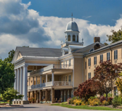

Reservations are to be made under the name
WNC Extension & Community Association.

Lake Junaluska Conference and Retreat Center
91 North Lakeshore Drive
Lake Junaluska, NC 28745

